
Arab Academy for Science, Technology & Maritime Transport
College of ………………………………………………
Branch …………………..
Project Final Evaluation Rubric
Subject: Embedded Systems. Date: _________________
Project Title: Maze-Solving-Robot-Right-Hand-Rule-with-PD-Wall-Following
Total Score: _____ / 100
Student Name | Student ID | Group
Abduallah Mohammed | 221017764 | 8CE2
Ali Ibrahim Katary | 221017764 | 8CE2
Mohammed Ashraf | 221017597 | 8CE2
Mohammed Mustafa Kamel | 221017636 | 8CE2

Team Scoring Summary
Category | Score | Max Points
Requirements & Functionality |  | 35
Code Quality & Documentation |  | 20
Hardware Integration & Design |  | 20
Testing & Verification |  | 15
Presentation & Demonstration |  | 10
TOTAL |  | 100

Grade: _______ / 100

TA Signature: _________________________

Instructor Signature: _________________________

Category 1: Requirements & Functionality (35 points)
Criteria | 5 Excellent | 4 Good | 3 Satisfactory | 2 Needs Improvement | 1-0 Poor | Score
Core functionality works | All features | One minor bug | Multiple minor bugs | Major feature missing | Not working | __/5
Peripheral integration | 3+ peripherals | 2 peripherals | 1 peripheral | Flawed | None | __/5
Input handling | All inputs responsive | Minor latency | Works but slow | Missing debouncing | Not working | __/5
Output accuracy | Perfect | Minor error | Within tolerance | Frequent errors | Wrong output | __/5
Error handling | Recovery implemented | Detection + reset | Detection only | Missing checks | None | __/5
User interface | Intuitive + feedback | Functional | Minimal | Confusing | None | __/5
Power management | Sleep + wakeup | Sleep mode only | Considered | None | N/A | __/5

Category 1 Subtotal: _____ / 35
Instructor Notes:
___________________________________________

Category 2: Code Quality & Documentation (20 points)
Criteria | 4 Excellent | 3 Good | 2 Satisfactory | 1 Needs Improvement | 0 Poor | Score
Code organization | Modular, clear structure | Good structure | Acceptable | Disorganized | Chaotic | __/4
Naming conventions | Consistent, meaningful | Mostly consistent | Inconsistent | Hard to follow | Meaningless | __/4
Comments | Comprehensive | Good coverage | Minimal | Sparse | None | __/4
Hardware abstraction | Clear separation | Good separation | Some separation | Tight coupling | None | __/4
Version control | Meaningful commits | Regular commits | Basic usage | Inconsistent | None | __/4

Category 2 Subtotal: _____ / 20
Instructor Notes:
___________________________________________

Category 3: Hardware Integration & Design (20 points)
Criteria | 5 Excellent | 4 Good | 3 Satisfactory | 2 Needs Improvement | 1-0 Poor | Score
Schematic/wiring | Professional, annotated | Good, minor issues | Acceptable sketch | Hard to follow | Missing | __/5
Component selection | Optimal, justified | Appropriate | Acceptable | Questionable | Wrong | __/5
Assembly quality | Professional | Good | Acceptable | Poor connections | Unsafe | __/5
Signal integrity | Clean signals | Minor noise | Functional | Significant noise | Not working | __/5
Category 3 Subtotal: _____ / 20
Instructor Notes:
___________________________________________

Category 4: Testing & Verification (15 points)
Criteria | 5 Excellent | 4 Good | 3 Satisfactory | 2 Needs Improvement | 1-0 Poor | Score
Test plan | Comprehensive, documented | Good coverage | Basic tests | Minimal | None | __/5
Test execution | All tests passed | Most passed | Critical tests only | Incomplete | None | __/5
Documentation | Test results recorded | Some recording | Verbal only | No evidence | Missing | __/5
Category 4 Subtotal: _____ / 15
Instructor Notes:
___________________________________________

Category 5: Presentation & Demonstration (10 points)
Criteria | 5 Excellent | 4 Good | 3 Satisfactory | 2 Needs Improvement | 1-0 Poor | Score
Project explanation | Clear, complete, professional | Good | Basic | Confusing | Unable | __/5
Live demonstration | Perfect, handles edge cases | Works with guidance | Works but slow | Frequent failures | No demo | __/5
Category 5 Subtotal: _____ / 10
Instructor Notes:
___________________________________________

Instructor Comments
Strengths:

Areas for Improvement:

Recommendation:

Photo/Picture Album: Filled by team!
Robot chassis showing motor assembly, L298N driver, and battery pack wiring

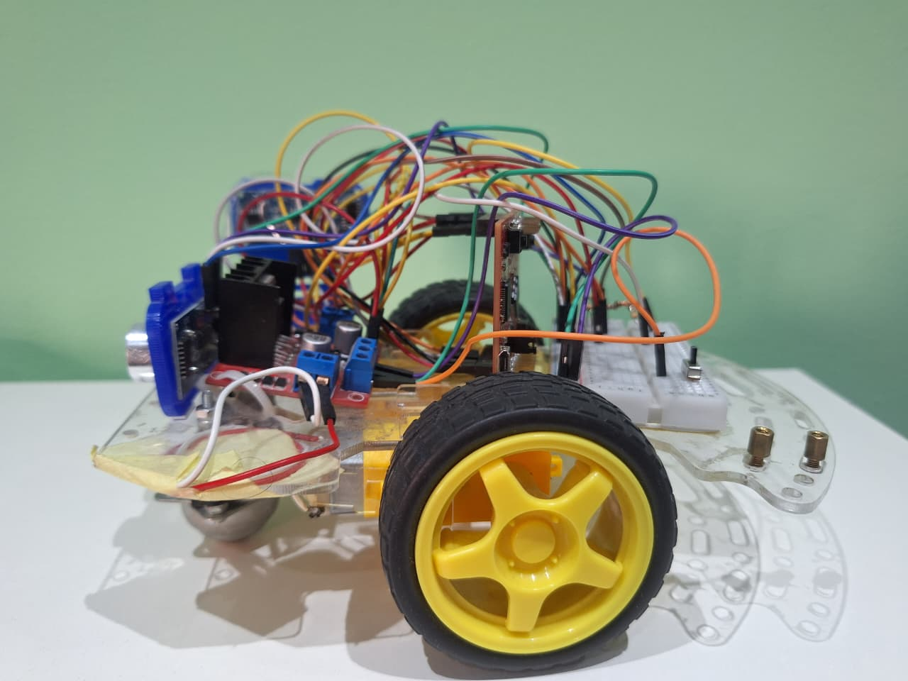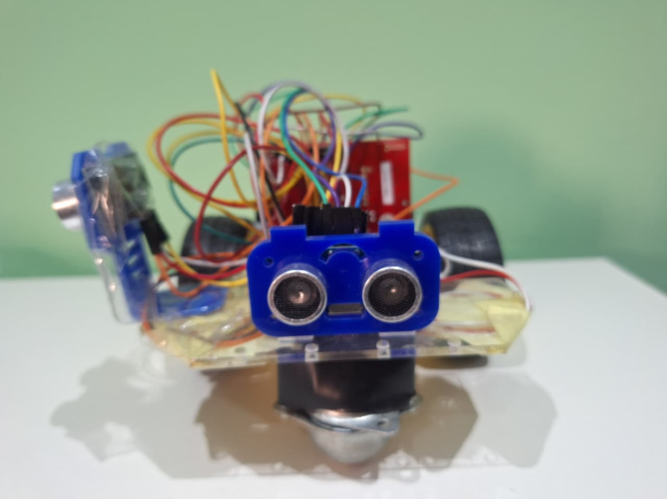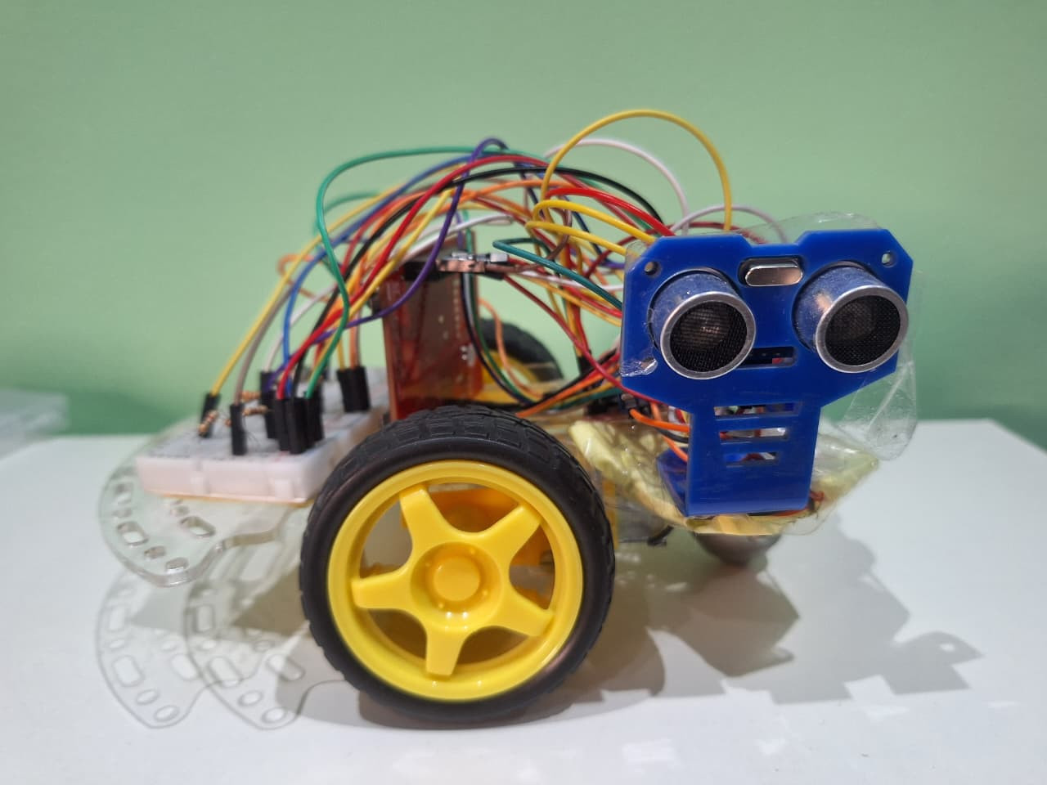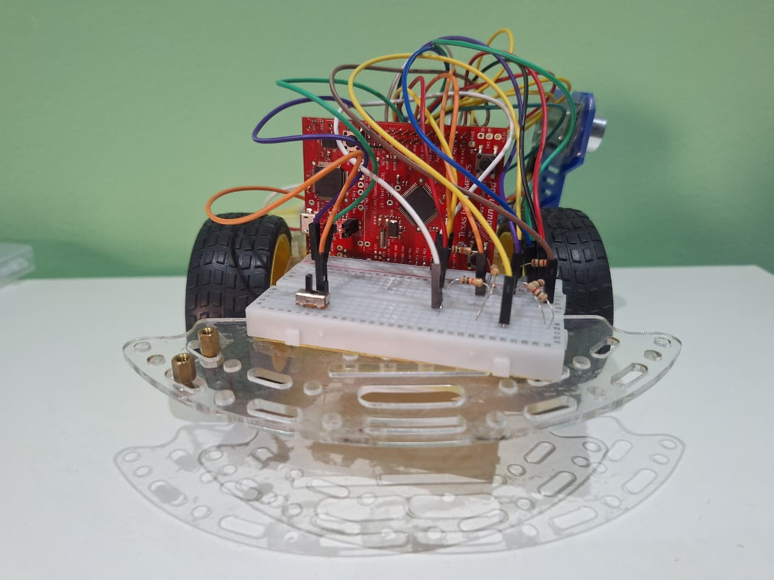
Robot navigating maze - right-hand wall-following in action

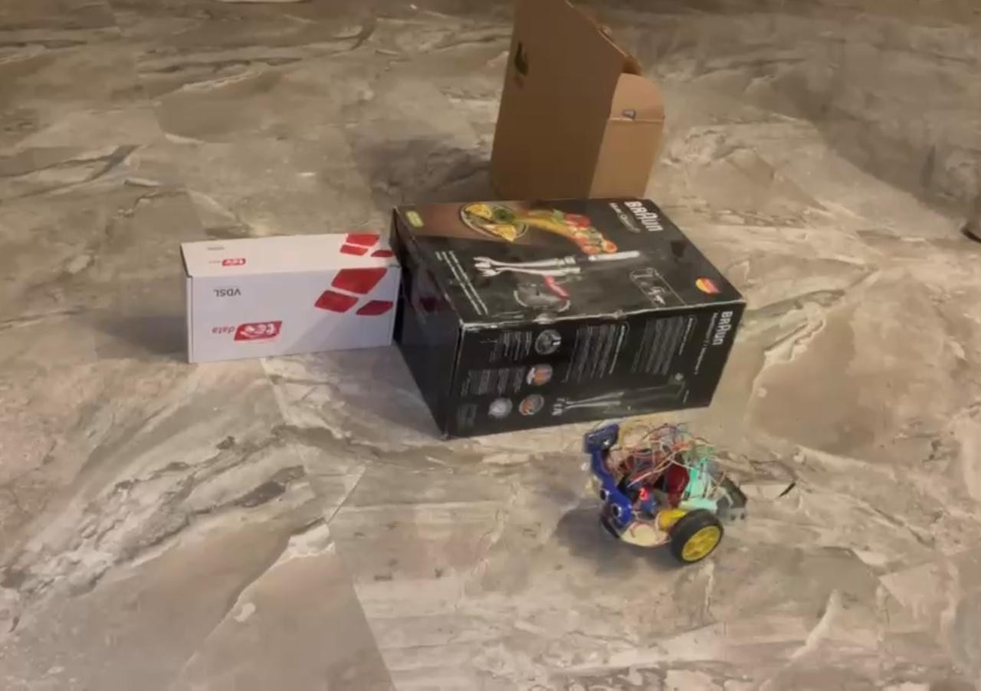
Testing Kp and Kd values to help the robot in using the PD controller to follow the wall in a straight line
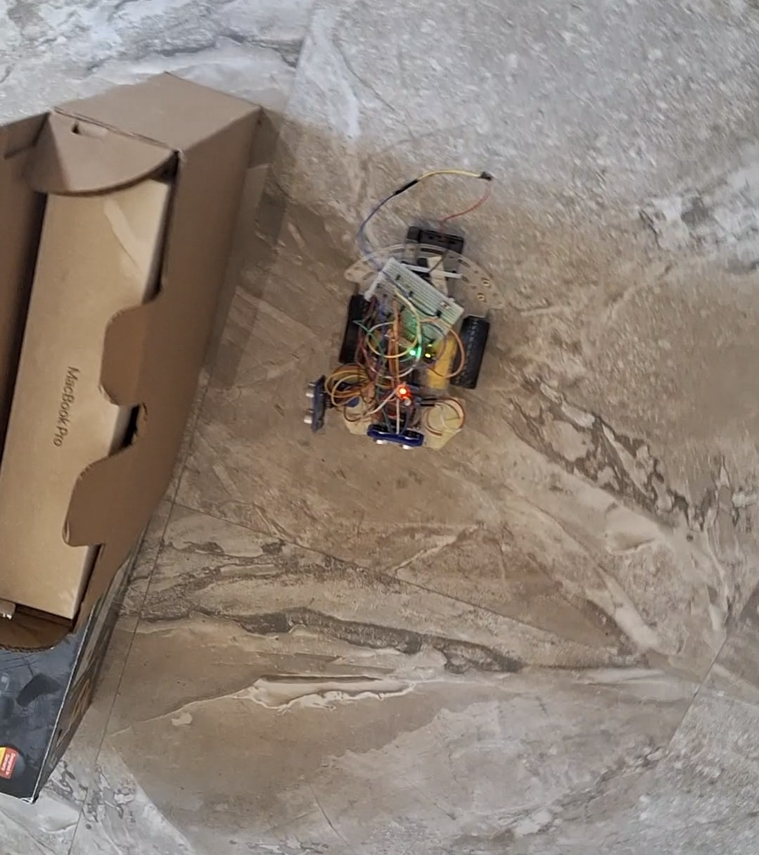

Team Efforts’ Evaluation DeclarationFilled by team!
Student Name | Student ID | Group | Task Description | Accomp-lishment (%) | Comment
Abduallah Mohamed | 221007888 | CE2 | PD controller implementation — tuned Kp=10, Kd=20 for smooth right-wall following at 12.5 cm target distance | 100%
Ali Ibrahim Katary | 221017764 | CE2 | Hardware assembly + voltage divider design — identified that HC-SR04 ECHO pin outputs 5V which is incompatible with Tiva C 3.3V GPIO, designed and built resistor voltage divider to safely scale signal down | 100%
Mohammed Ashraf | 221017597 | CE2 | Hardware assembly — chassis build, motor mounting, sensor placement, L298N and wiring integration | 100%
Mohammed Mustafa Kamel | 221017636 | CE2 | Motor direction logic — right-hand rule state machine (gap detection, front-wall avoidance, wall-following transitions) | 100%

Team Signatures Filled by team!
Name, ID | Signature
Abduallah Mohamed, 221007888 | Abduallah Mohamed
Ali Ibrahim Katary, 221017764 | Ali Ibrahim Katary
Mohammed Ashraf, 221017597 | Mohammed Ashraf
Mohammed Mustafa Kamel, 221017636 | Mohammed Mustafa Kamel

